**CASE STUDY**

1. Sign-in page

CODE:

<!DOCTYPE html>

<html lang="en">

<head>

<meta charset="UTF-8">

<meta name="viewport" content="width=device-width, initial-scale=1.0">

<title>Stylish Login Page</title>

<style>

body {

font-family: Arial, sans-serif;

background-color: #f4f4f4;

margin: 0;

padding: 0;

display: flex;

justify-content: center;

align-items: center;

height: 100vh;

}

.login-container {

background-color: white;

height:420px;

width: 280px;

padding: 50px;

border-radius: 20px;

box-shadow: 0 0 20px rgba(0, 0, 0, 0.5);

}

.login-container h1 {

text-align: center;

color: #333;

margin-bottom: 50px;

}

.login-container input[type="text"],

.login-container input[type="password"] {

width: 100%;

padding: 10px;

margin-bottom: 30px;

border: 1px solid #3cb371;

box-shadow: 0 0 20px rgba(0, 0, 0, 0.3);

border-radius: 5px;

outline: none;

}

.login-container input[type="submit"] {

width: 100%;

padding: 10px;

background-color: #007bff;

color: #fff;

border: none;

border-radius: 7px;

cursor: pointer;

transition: background-color 0.3s;

outline: none;

}

.login-container input[type="submit"]:hover {

background-color: #0056b3;

}

.login-container .register-link {

text-align: center;

}

.login-container .register-link a {

color: #007bff;

text-decoration: none;

}

</style>

</head>

<body>

<div class="login-container">

<h1>Sign in</h1>

<form action="#" method="post">

<input type="text" name="username" placeholder="Username" required>

<input type="password" name="password" placeholder="Password" required>

<input type="submit" value="Login">

</form>

<div class="register-link">

Don't have an account? <a href="Register.html" target="_blank">Register</a>

</div>

</div>

</body>

</html>

OUTPUT:

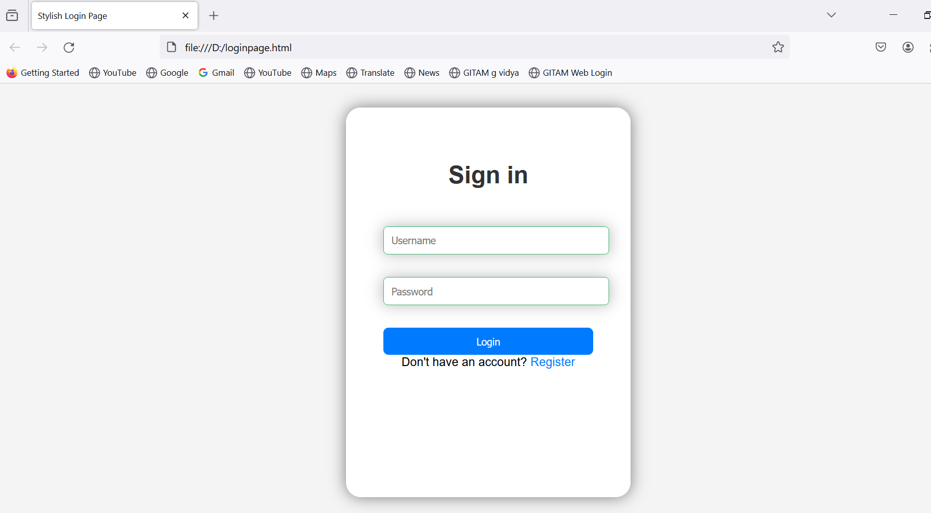

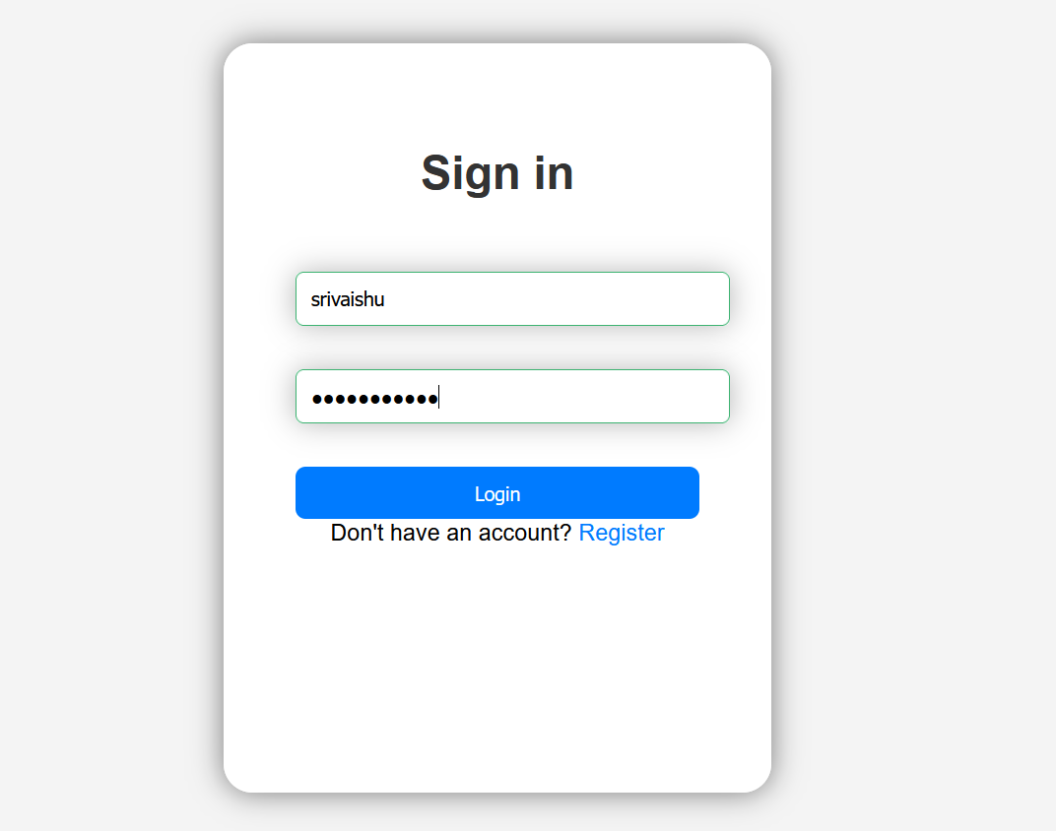

1. Register page: After clicking on register in goes to register page in new tab.

CODE:

<!DOCTYPE html>

<html lang="en">

<head>

<meta charset="UTF-8">

<meta name="viewport" content="width=device-width, initial-scale=1.0">

<title>Stylish Login Page</title>

<style>

body {

font-family: Arial, sans-serif;

background-color: #f4f4f4;

margin: 0;

padding: 0;

display: flex;

justify-content: center;

align-items: center;

height: 100vh;

}

.login-container {

background-color: white;

height:420px;

width: 280px;

padding: 50px;

border-radius: 20px;

box-shadow: 0 0 20px rgba(0, 0, 0, 0.5);

}

.login-container h1 {

text-align: center;

color: #333;

margin-bottom: 50px;

}

.login-container input[type="text"],

.login-container input[type="password"] {

width: 100%;

padding: 10px;

margin-bottom: 30px;

border: 1px solid #3cb371;

border-radius: 5px;

outline: none;

}

.login-container input[type="submit"] {

width: 100%;

padding: 10px;

background-color: #007bff;

color: #fff;

border: none;

border-radius: 7px;

cursor: pointer;

transition: background-color 0.3s;

outline: none;

}

.login-container input[type="submit"]:hover {

background-color: #0056b3;

}

.login-container .register-link {

text-align: center;

}

.login-container .register-link a {

color: #007bff;

text-decoration: none;

}

</style>

<body>

<div class="login-container">

<h1><b>Register</b></h1>

<i>Username</i> <input type="text" name="Username" placeholder ="Username" required>

<i>Mobile number</i><input type="text" name="Moblie number" placeholder="Moblie number" required>

<i>Password</i><input type="Password" name="Password" placeholder="Password" required>

<input type="submit" value="Verify mobile number">

<div class="register-link">

Already have an account? <a href="loginpage.html" target="_self">Sign up</a>

</div>

</div>

</body>

</html>

OUTPUT:

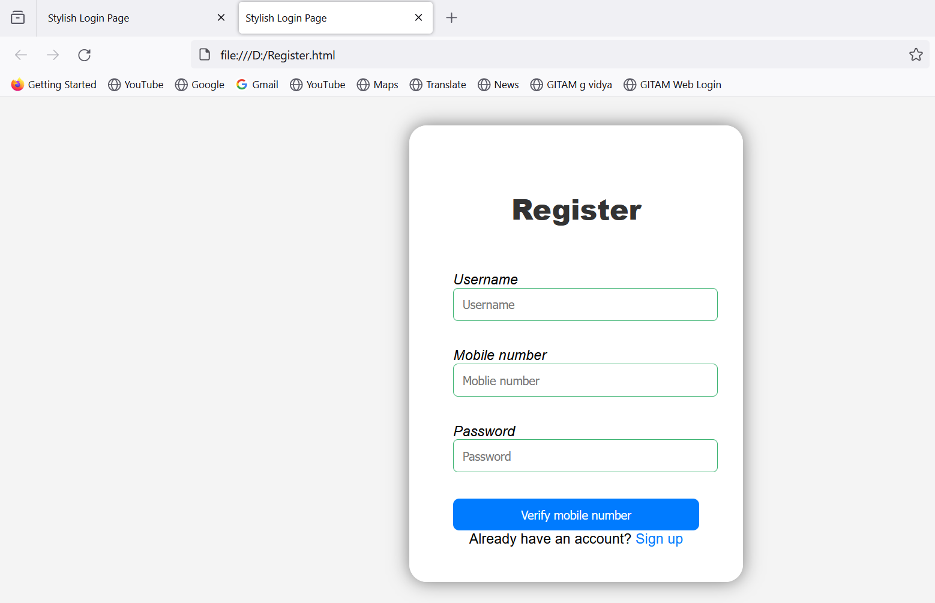

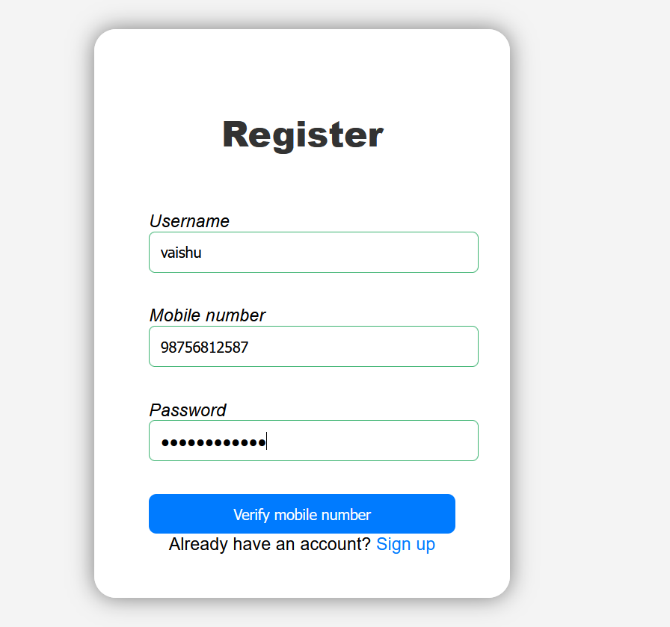

1. Home page:

CODE:

<!DOCTYPE html>

<html lang="en">

<head>

<meta charset="UTF-8">

<meta name="viewport" content="width=device-width, initial-scale=1.0">

<title>Modern Stylish 3D Home Page</title>

<style>

body {

margin: 0;

padding: 0;

font-family: Arial, sans-serif;

background-color: #f0f0f0;

}

.container {

width: 80%;

margin: 50px auto;

padding: 20px;

background-color: #fff;

border-radius: 20px;

box-shadow: 0 0 20px rgba(0, 0, 0, 0.1);

}

header {

background-color: #3498db;

color: #fff;

padding: 50px;

border-radius: 20px 20px 0 0;

}

header h1 {

font-size: 36px;

margin-bottom: 10px;

}

header p {

font-size: 18px;

}

main {

padding: 50px;

}

section {

border-bottom: 1px solid #ccc;

margin-bottom: 40px;

padding-bottom: 40px;

}

section h2 {

font-size: 24px;

color: #333;

}

section p {

font-size: 16px;

color: #555;

line-height: 1.6;

}

footer {

background-color: #34495e;

color: #fff;

padding: 20px;

border-radius: 0 0 20px 20px;

}

footer p {

font-size: 16px;

}

</style>

</head>

<body>

<div class="container">

<header>

<h1>Welcome to Our Laundry service</h1>

<p>Learn how live in modern life with saving time</p>

</header>

<main>

<section>

<h2>About Us</h2>

<p>In our company laundry is done systematically. We use the best product to remove stains on clothes. After picking up the order from the customer we divide the clothes according to the customer's needs. After the separation, we start the process by using our best products to maintain the quality of the clothes. It takes at least two to four days to complete the process as we use UV rays to dry the clothes.Then we deliver the clothes to customers on time. We also provide discounts based on the quantity of the clothes the customer gives and we make sure to return clothes to them by handling them with good care. We make sure to give the delivery on time as much as possible.</p>

</section>

</main>

<footer>

<pre>Contact us: prbabu19721972@gmail.com

Address: Asilmeta, Komadi,Andhra Pradesh</pre>

</footer>

</div>

</body>

</html>

OUTPUT:

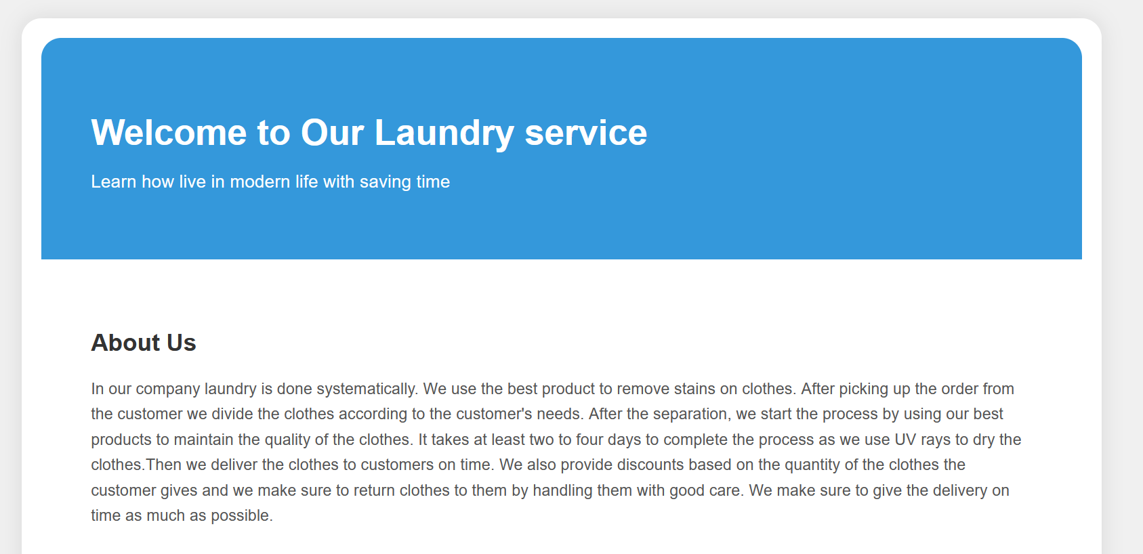

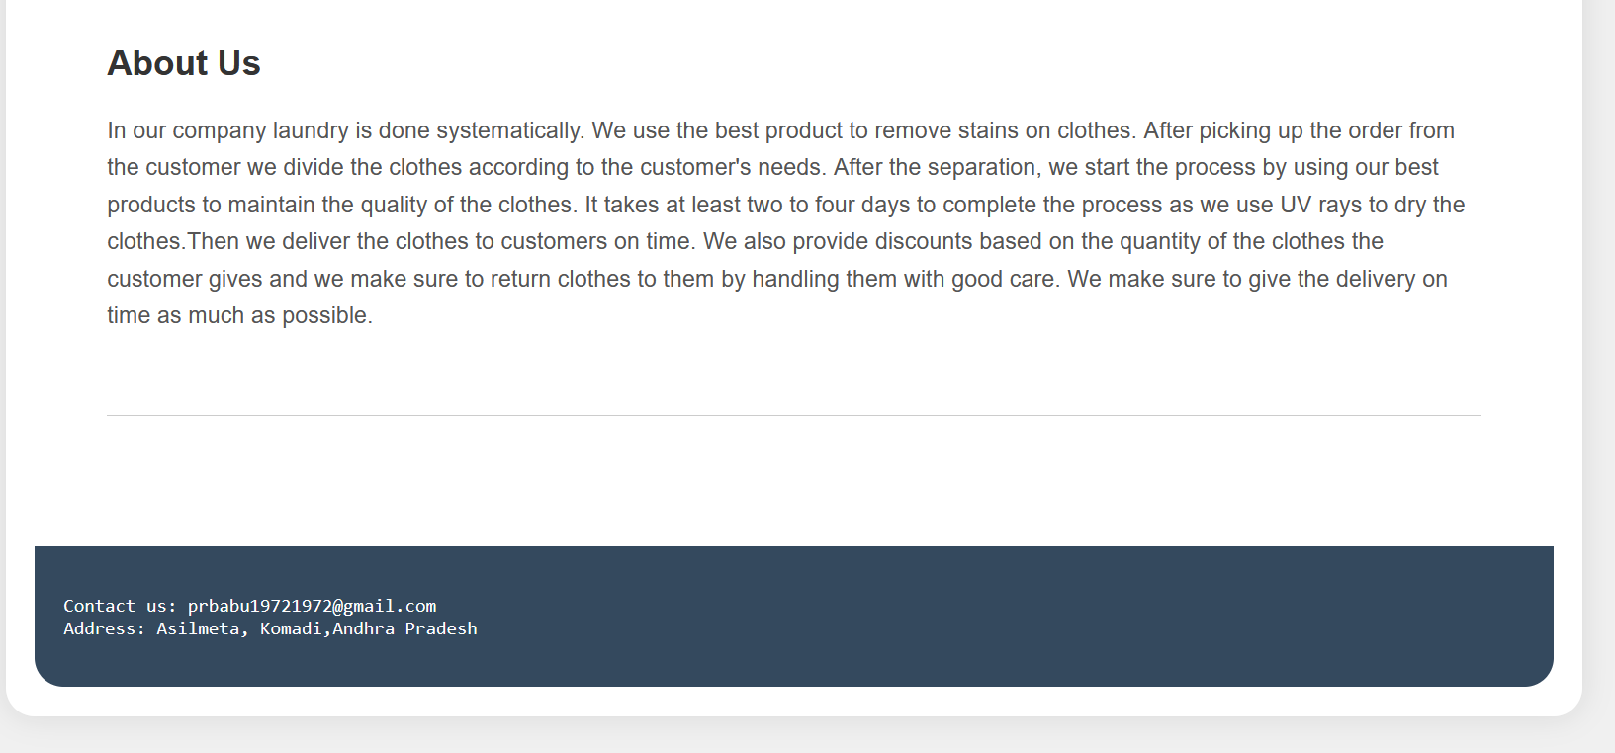

1. Another home page:

CODE:

<!DOCTYPE html>

<html lang="en">

<head>

<meta charset="UTF-8">

<meta name="viewport" content="width=device-width, initial-scale=1.0">

<title>Home Page with Image Content</title>

<style>

body {

font-family: Arial, sans-serif;

background-color: white;

margin: 0;

padding: 0;

position: relative; /* Added */

}

header {

background-image: url('5.jpg');

color: black;

padding: 100px;

text-align: bottom;

background-position: center;

background-size: 22%;

}

.container {

max-width: 1200px;

margin: auto;

padding: 40px;

text-align: center;

overflow-x: auto;

}

.services {

display: flex;

justify-content: center;

gap: 100px;

padding: 50px;

}

.service {

flex: 0 0 auto;

width: 120px;

text-align: center;

}

.service img {

display: block;

margin: 0 auto;

width: 130px;

height: auto;

}

.service p {

font-size: 16px;

margin-top: 15px;

}

.wrapper{

margin: 150px auto;

width: 95%;

}

img{

max-width: 350px;

float: right;

}

.text-box p{

font-size: 25px;

text-align: center;

}

/* Added CSS for dashes */

.dashes {

position: absolute;

top: 20px;

right: 20px;

font-size: 30px;

}

</style>

</head>

<body>

<header>

<h1></h1>

</header>

<div class="container">

<h1 style="text-align:center">Our Services</h1>

<div class="services">

<div class="service">

<a href="image1.jpg" target="_blank"><img src="1.jpg" alt="Dry Cleaning" height="300" width="300"></a>

<p>Dry cleaning</p>

</div>

<div class="service">

<a href="image2.jpg" target="_blank"><img src="2.jpg" alt="Laundry" height="150" width="150"></a>

<p>Laundry</p>

</div>

<div class="service">

<a href="image3.jpg" target="_blank"><img src="3.jpg" alt="Stream iron" height="150" width="150"></a>

<p>Stream iron</p>

</div>

<div class="service">

<a href="image6.jpg" target="_blank"><img src="6.jpg" alt="Rolling" height="150" width="150"></a>

<p>Rolling</p>

</div>

<div class="service">

<a href="image6.jpg" target="_blank"><img src="7.jpg" alt="Rolling" height="100" width="100"></a>

<p>Petroleum wash</p>

</div>

</div>

</div>

<div class="wrapper">

<img src="8.jpg" alt="Rolling" height="300" width="300"></a>

<div class= "text-box">

<p>In our company laundry is done systematically. We use the best product to remove stains on clothes. After picking up the order from the customer we divide the clothes according to the customer's needs. After the separation, we start the process by using our best products to maintain the quality of the clothes. It takes at least two to four days to complete the process as we use UV rays to dry the clothes.Then we deliver the clothes to customers on time. We also provide discounts based on the quantity of the clothes the customer gives and we make sure to return clothes to them by handling them with good care. We make sure to give the delivery on time as much as possible.</p>

</div>

</div>

<!-- Three dashes -->

<div class="dashes">---</div>

</body>

</html>

OUTPUT:

